Streamlining Ticket Assignment for Efficient Support Operations

Team ID : NM2025TMID17531

Team Size : 4

Team Leader : Abisha.A

Team member : Bebinjo.R

Team member : Karthirvel.S

Team member : Shalini.S

# Problem Statement:

The objective of this initiative is to implement an automated system for ticket routing at ABC Corporation, aimed at improving operational efficiency by accurately assigning support tickets to the appropriate teams. This solution aims to reduce delays in issue resolution, enhance customer satisfaction, and optimize resource utilization within the support department.

# Objective:

* To automate the routing and assignment of support tickets.
* To reduce ticket resolution time by ensuring quick allocation.
* To improve the accuracy of ticket categorization and assignment.
* To optimize workload distribution among support agents.
* To enhance customer satisfaction through faster responses.
* To enable data-driven decision-making with ticket analytics.
* To ensure scalability and adaptability of the support system.

# Skills:

1. Oracle DB

# TASK INITIATION:

Milestone 1

**Create Users**

1. Open service now.
2. Click on All  >> search for users
3. Select Users under system security
4. Click on new
5. Fill the following details to create a new user  
   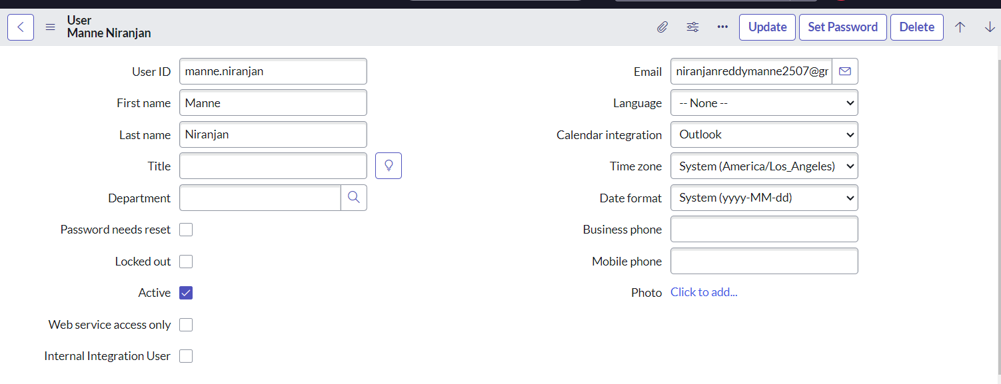
6. Click on submit  
     
   Create one more user:
7. Create another user with the following details  
   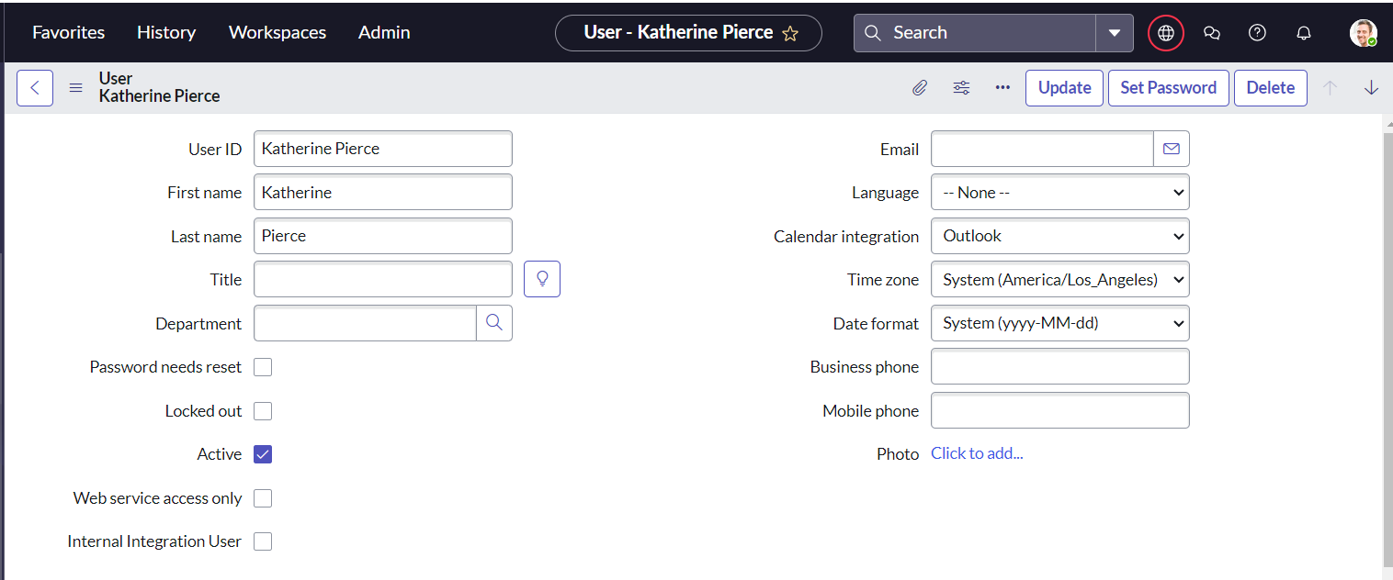
8. Click on submit

Milestone 2

**Create Groups**

Open service now.

1. Click on All  >> search for groups
2. Select groups under system security
3. Click on new
4. Fill the following details to create a new group  
   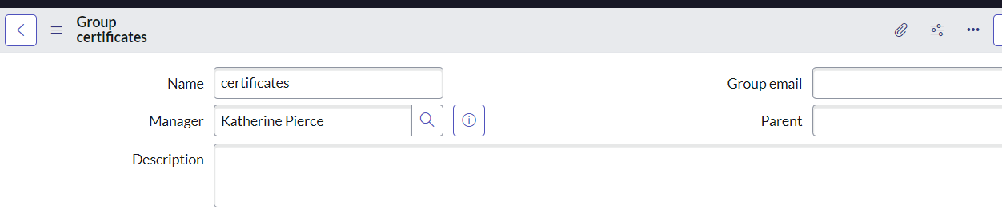
5. Click on submit
6. Create one more group:
7. Create another group with the following details  
   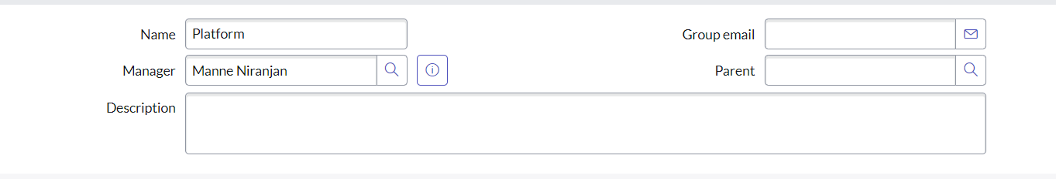

Click on submit

## Milestone 3

**Create roles**

1. Open service now.
2. Click on All  >> search for roles
3. Select roles under system security
4. Click on new
5. Fill the following details to create a new role  
   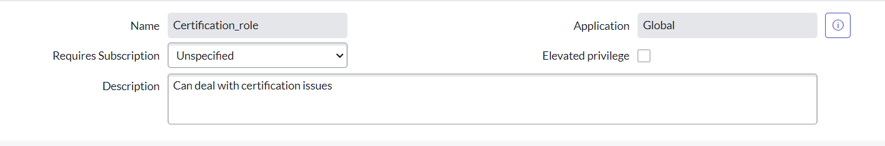
6. Click on submit
7. Create one more role:
8. Create another role with the following details

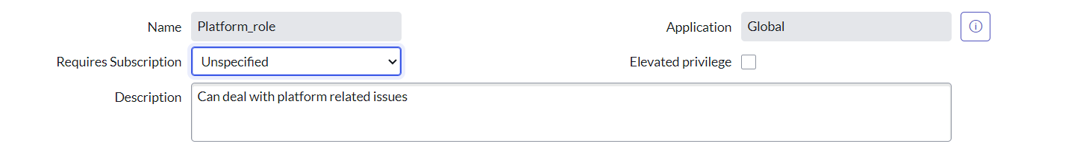

Click on submit

## Milestone 4

**Create Table**

* 1. Open service now.
  2. Click on All  >> search for tables
  3. Select tables under system definition
  4. Click on new
  5. Fill the following details to create a new table  
     Label : Operations related  
     Check the boxes Create module & Create mobile module
  6. Under new menu name : Operations related
  7. Under table columns give the columns  
     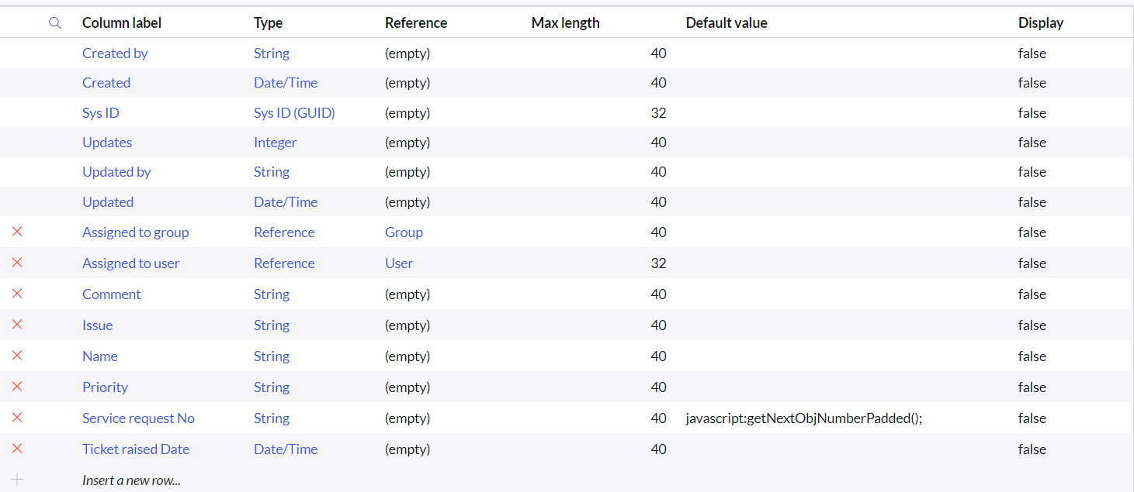
  8. Click on submit

Create choices for the issue filed by using form design  
Choices are

* 1. unable to login to platform
  2. 404 error
  3. regarding certificates
  4. regarding user expired

## Milestone 5

**Assign roles & users to certificate group**

1. Open service now.
2. Click on All  >> search for tables
3. Select tables under system definition
4. Select the certificates group
5. Under group members
6. Click on edit
7. Select Katherine Pierce and save
8. Click on roles
9. Select Certification_role and save

**Assign roles & users to certificate group**

1. Open service now.
2. Click on All  >> search for tables
3. Select tables under system definition
4. Select the certificates group
5. Under group members
6. Click on edit
7. Select Katherine Pierce and save
8. Click on roles
9. Select Certification_role and save

## Milestone 6

**Assign role to table**

1. Open service now.
2. Click on All  >> search for tables
3. Select operations related table
4. Click on the Application Access
5. Click on u_operations_related read operation
6. Click on the profile on top right side
7. Click on elevate role
8. Click on security admin and click on update
9. Under Requires role
10. Double click on insert a new row
11. Give platform role
12. And add certificate role
13. Click on update  
    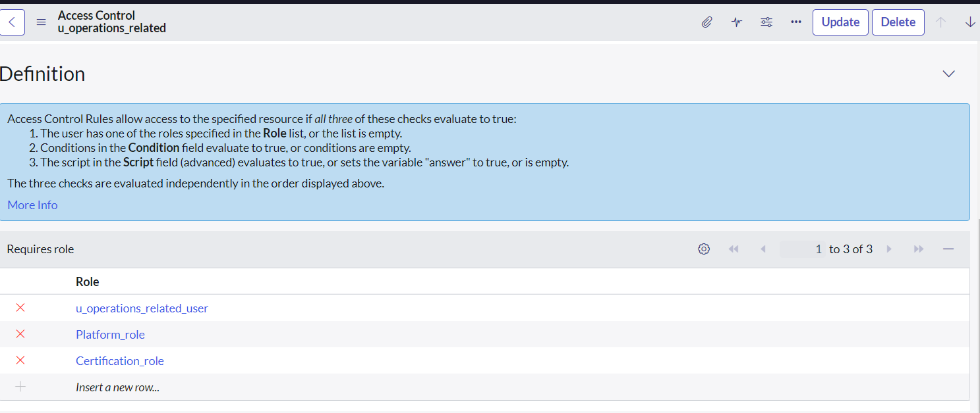
14. Click on u_operations_related write operation
15. Under Requires role
16. Double click on insert a new row
17. Give platform role
18. And add certificate role

## Milestone 7

**Assign role to table**

1. Open service now.
2. Click on All  >> search for tables
3. Select operations related table
4. Click on the Application Access
5. Click on u_operations_related read operation
6. Click on the profile on top right side
7. Click on elevate role
8. Click on security admin and click on update
9. Under Requires role
10. Double click on insert a new row
11. Give platform role
12. And add certificate role
13. Click on update  
    
14. Click on u_operations_related write operation
15. Under Requires role
16. Double click on insert a new row
17. Give platform role
18. And add certificate role

## Milestone 8

**Create ACL**

1. Open service now.
2. Click on All  >> search for ACL
3. Select Access Control(ACL) under system security
4. Click on new
5. Fill the following details to create a new ACL  
   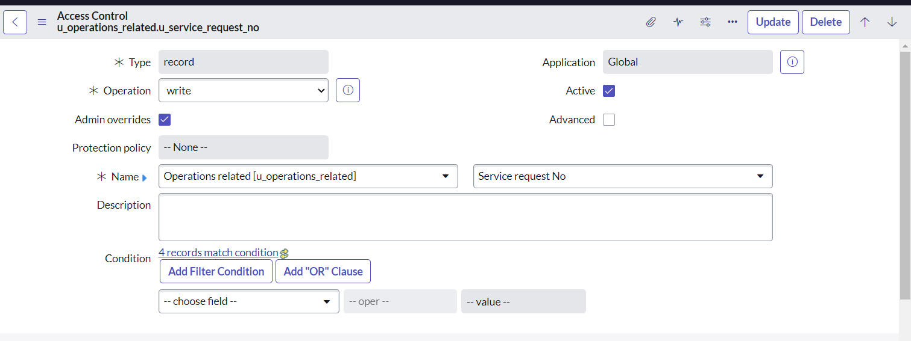
6. Scroll down under requires role
7. Double click on insert a new row
8. Give admin role
9. Click on submit
10. Similarly create 4 acl for the following fields  
    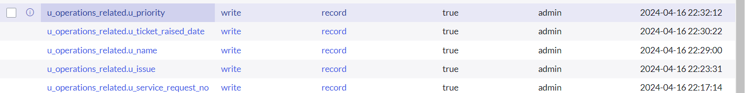

## Milestone 9

**Create a Flow to Assign operations ticket to group**

1. Open service now.
2. Click on All  >> search for Flow Designer
3. Click on Flow Designer under Process Automation.
4. After opening Flow Designer Click on new and select Flow.
5. Under Flow properties Give Flow Name as “ Regarding Certificate”.
6. Application should be Global.
7. Select Run user as “ System user ” from that choice.
8. Click on Submit.

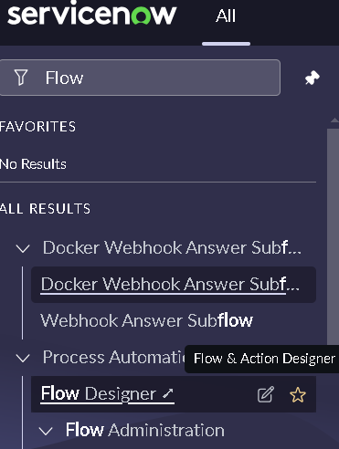

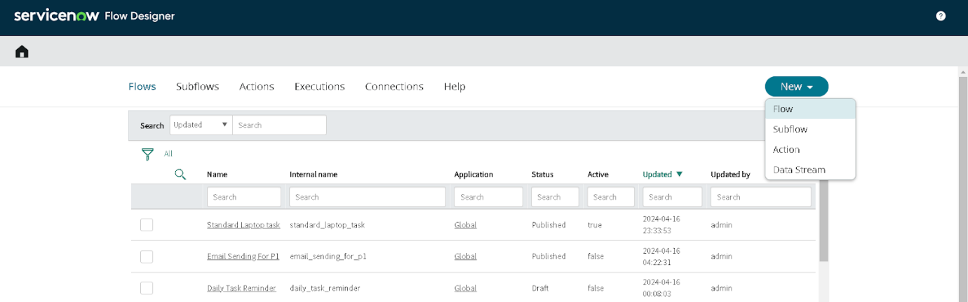

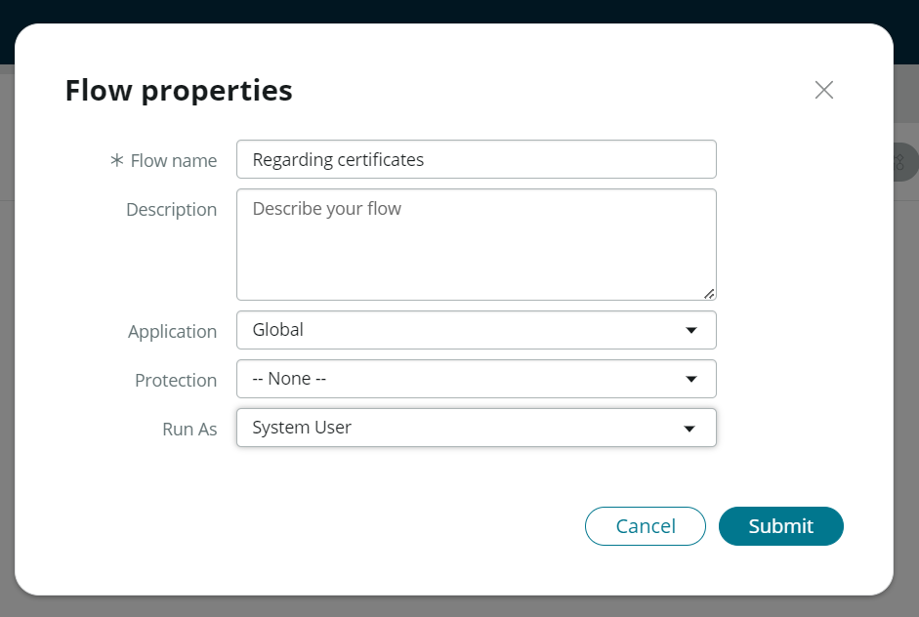

1. Click on Add a trigger
2. Select the trigger in that Search for “create or update a record”  and select that.
3. Give the table name as “ Operations related ”.
4. Give the Condition as  
   Field : issue

Operator : is

Value : Regrading Certificates

1. After that click on Done.

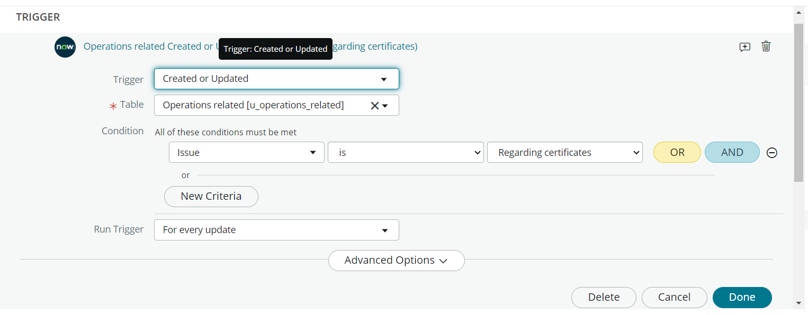

1. Now under Actions.
2. Click on Add an action.
3. Select action in that search for “ Update Record ”.
4. In Record field drag the fields from the data navigation from left side
5. Table will be auto assigned after that
6. Give the field as “ Assigned to group ”
7. Give value as “ Certificates ”
8. Click on Done.
9. Click on Save to save the Flow.
10. Click on Activate.

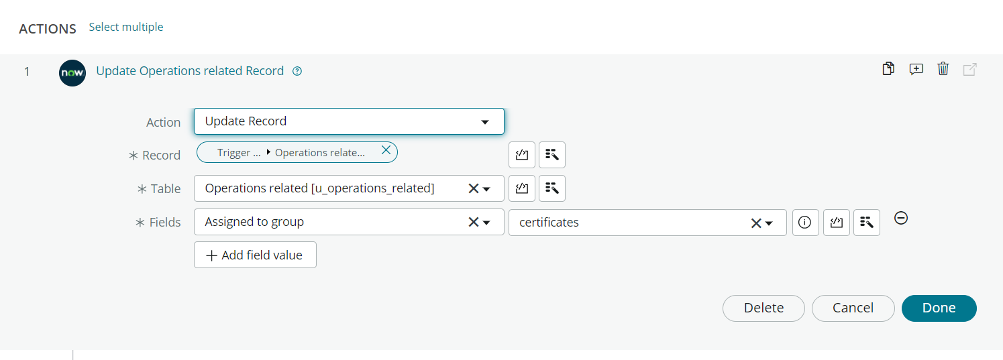

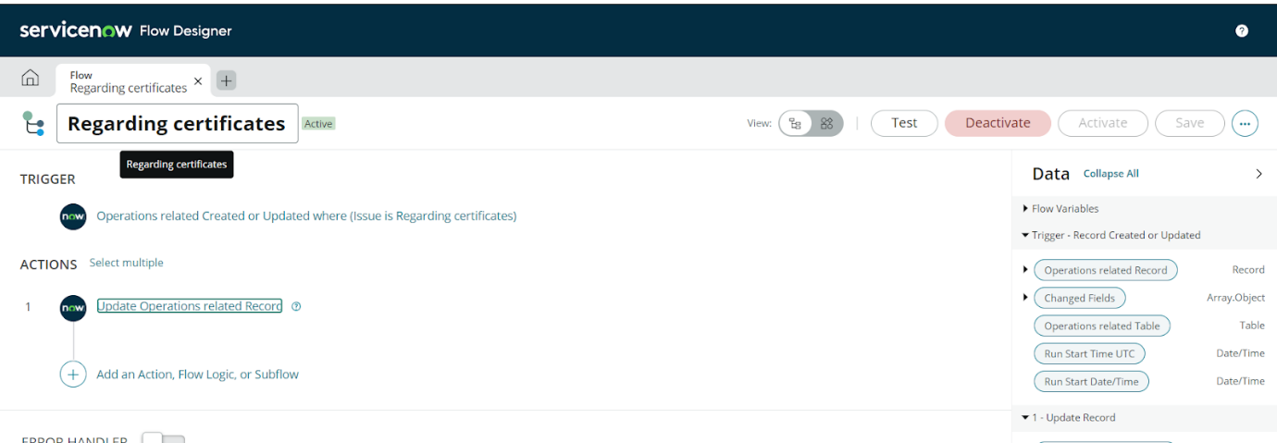

**Create a Flow to Assign operations ticket to Platform group**

1. Open service now.
2. Click on All  >> search for Flow Designer
3. Click on Flow Designer under Process Automation.
4. After opening Flow Designer Click on new and select Flow.
5. Under Flow properties Give Flow Name as “ Regarding Platform ”.
6. Application should be Global.
7. Select Run user as “ System user ” from that choice.
8. Click on Submit.

1. Click on Add a trigger
2. Select the trigger in that Search for “create or update a record”  and select that.
3. Give the table name as “ Operations related ”.
4. Give the Condition as  
   Field : issue

Operator : is

Value : Unable to login to platform

Click on New Criteria

Field : issue

Operator : is

Value : 404 Error

Click on New Criteria

Field : issue

Operator : is

Value : Regrading User expired

After that click on Done.

1. Now under Actions.
2. Click on Add an action.
3. Select action in that search for “ Update Record ”.
4. In Record field drag the fields from the data navigation from left side
5. Table will be auto assigned after that
6. Give the field as “ Assigned to group ”.
7. Give value as “ Platform ”.
8. Click on Done.
9. Click on Save to save the Flow.
10. Click on Activate.

## Conclusion

The implementation of the automated ticket routing system at ABC Corporation has been a significant success. By leveraging the capabilities of ServiceNow, we have streamlined the process of assigning support tickets to the appropriate teams, addressing the challenges of manual routing, and ensuring timely resolution of issues.